Network hardware
Y12 - Cambridge International 9618 | 2.1.6 | Student booklet
Name: _______________________________ | Date: _____________

This booklet has everything you need for the lesson in one place. Work through it in order:
- Learn sections show the key slides. Read them carefully - they explain the ideas and show worked examples.
- Task sections are where you practise. Each task uses what the slides just before it taught you.
- Tasks get harder as you go and use real Cambridge 9618 Paper 1 questions. Task 6 is extension or homework.
Do Task 1 from memory before you turn the page.
Task 1 Recall test - wired and wireless networking [10 marks]
Closed book. 7 minutes.
1 Tick one box in each row to show which cable each statement describes. [3]
Statement | Twisted pair | Coaxial | Fibre optic
Transmits data as pulses of light
The cheapest cable and the most common in LANs, but affected most by interference
Commonly used in MANs and by cable television companies

2 Copper cable can be used to transmit data in a network. Complete the table by identifying and describing two other transmission media. [4]
Based on 9618/13 October/November 2024 Q9(b).
Transmission medium | Description

3 Melinda mainly uses the internet to watch films and play computer games. Tick one box to identify whether Melinda should connect to the router using a wired or wireless network and justify your choice. [3]
9618/11 May/June 2021 Q4(c)(ii).
Wired |  | Wireless
Justification

Learn Inside every device: NIC, WNIC and addresses
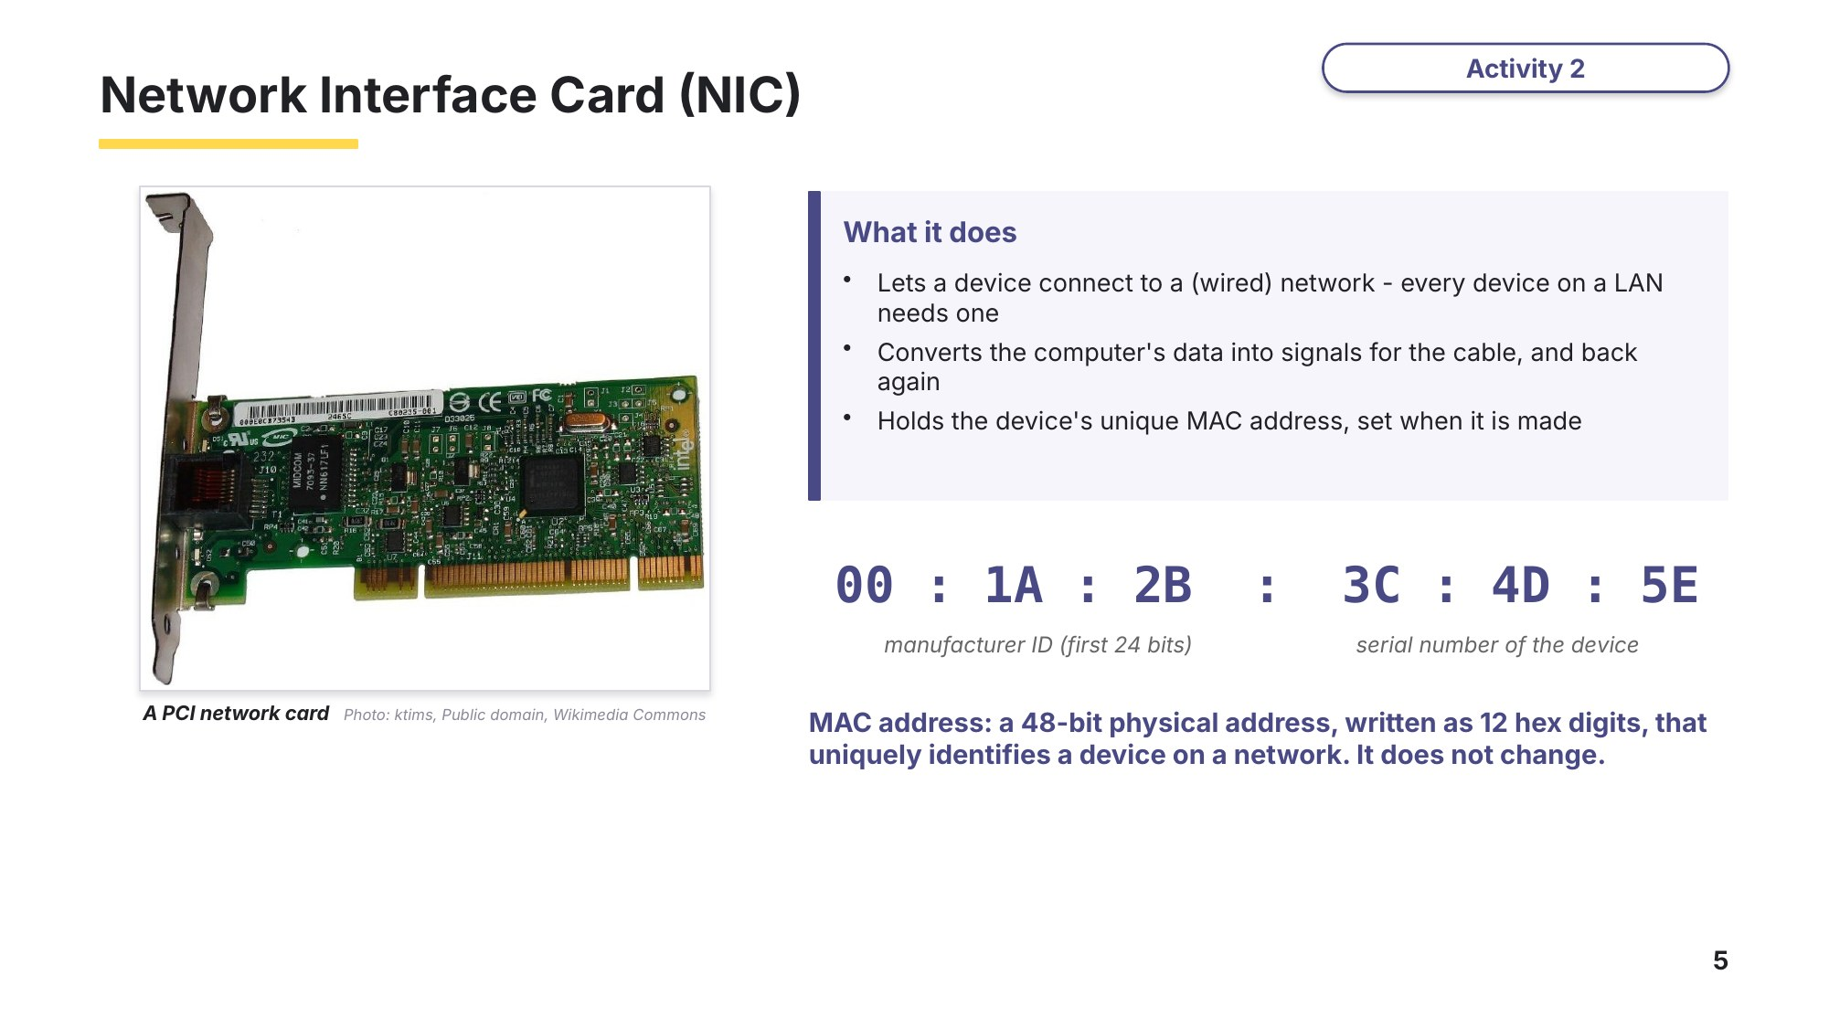
Slide 5 - Network Interface Card (NIC)
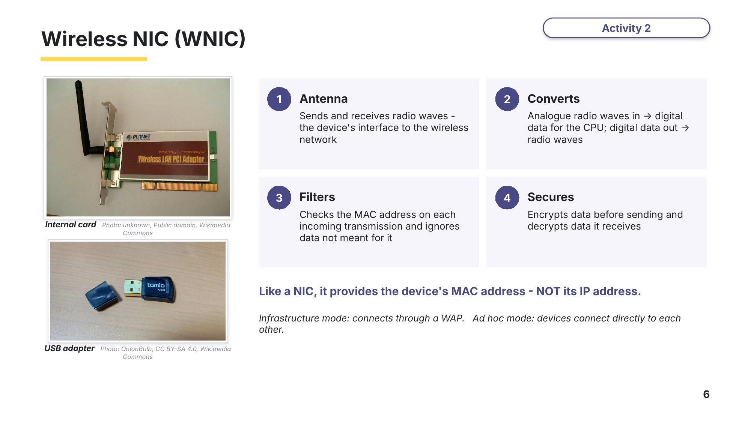
Slide 6 - Wireless NIC (WNIC)
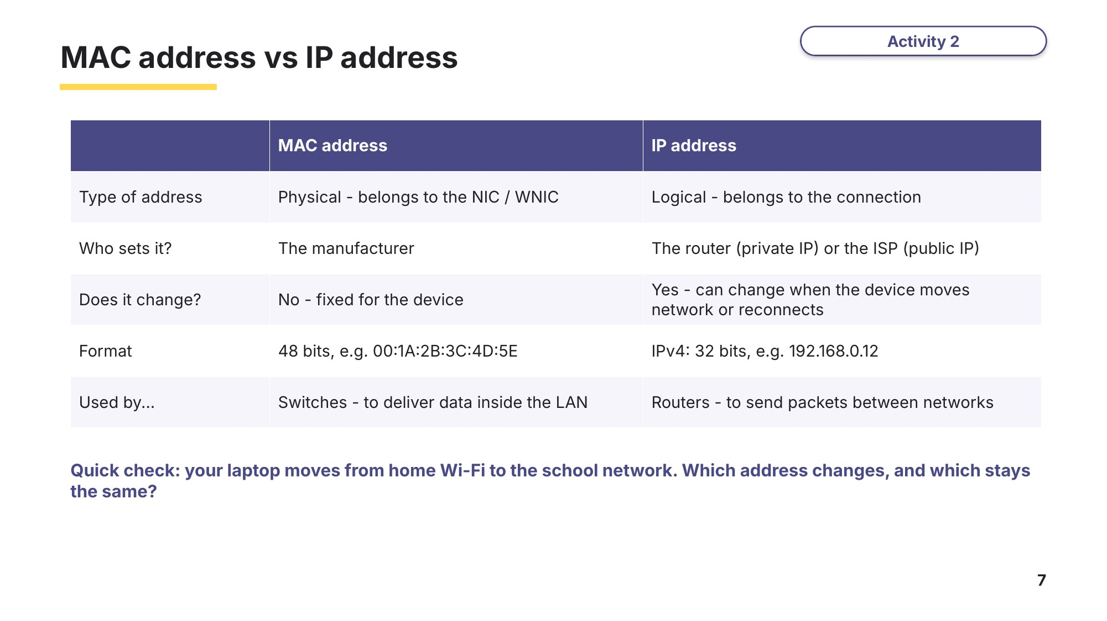
Slide 7 - MAC address vs IP address

Learn Connecting devices: hub, switch and WAP
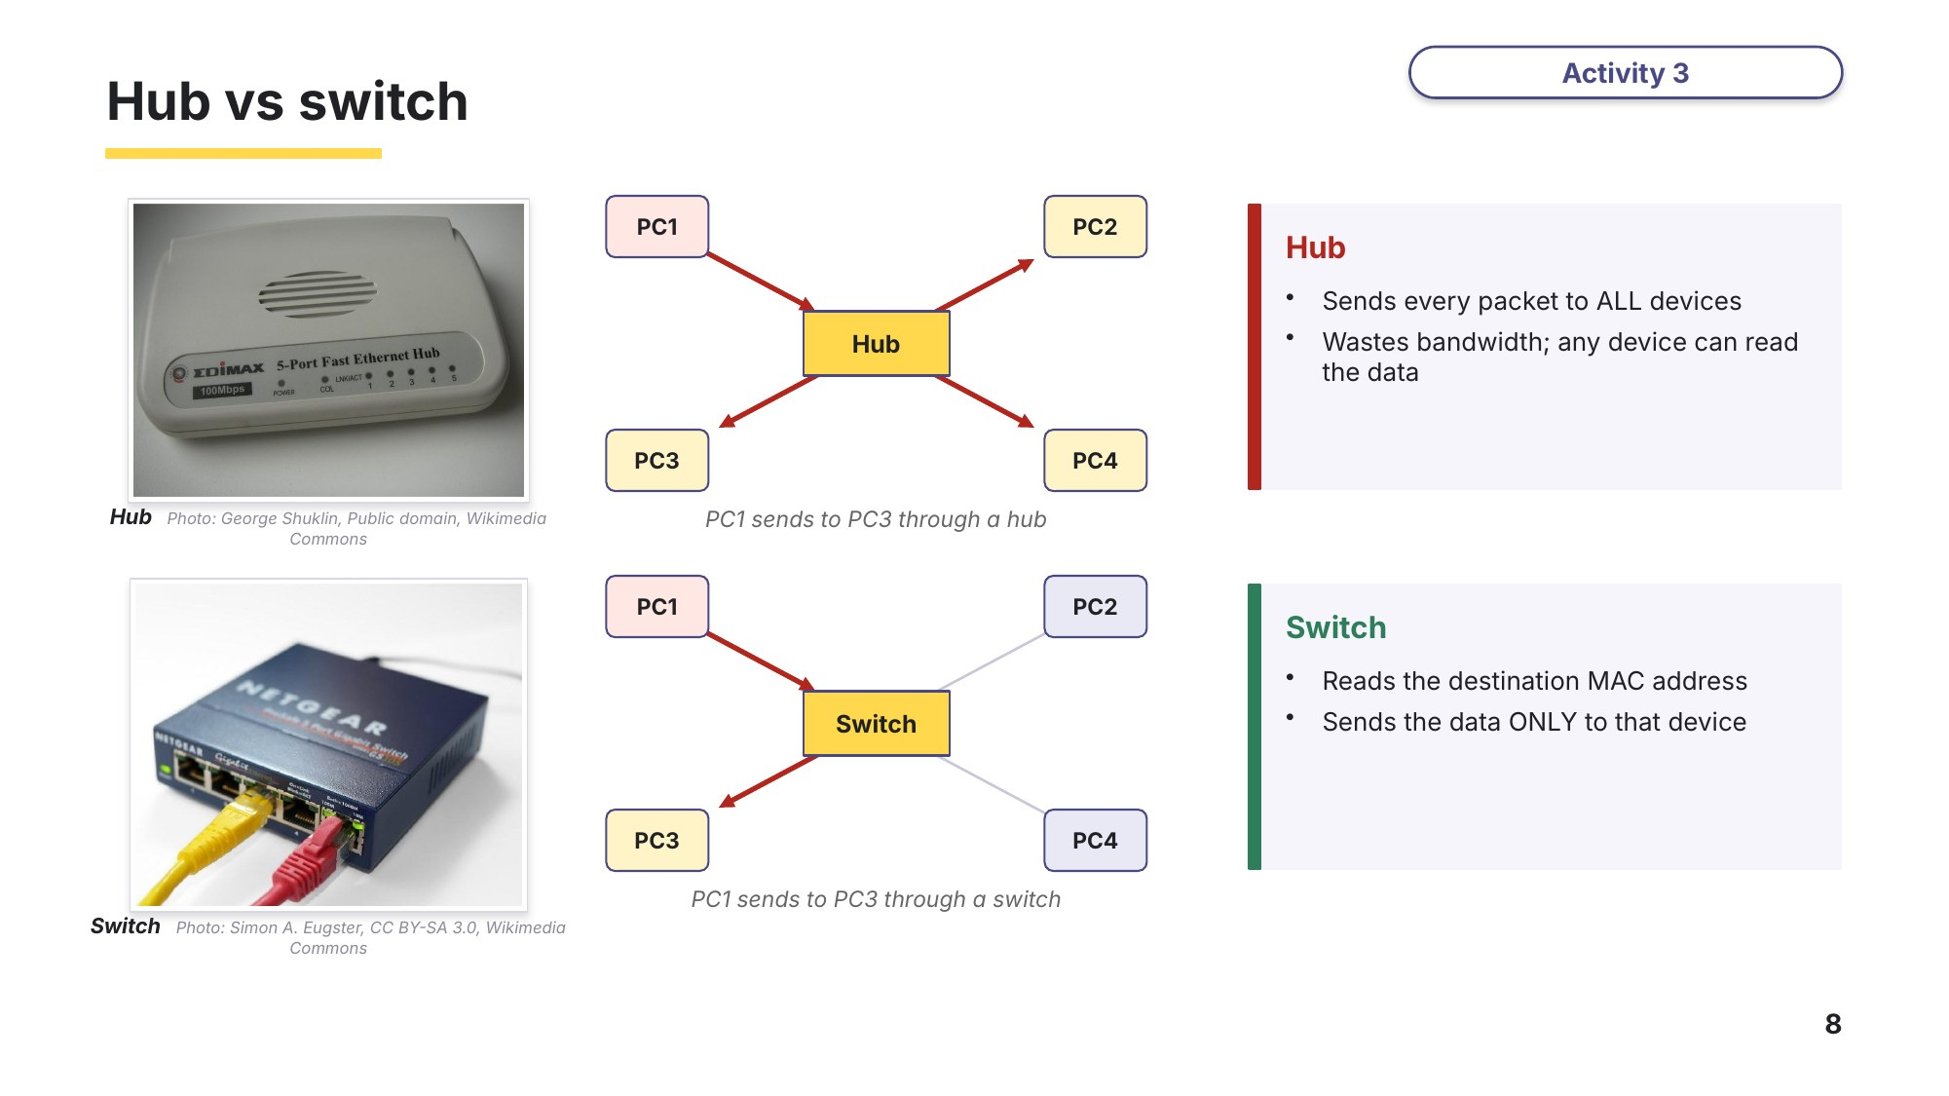
Slide 8 - Hub vs switch
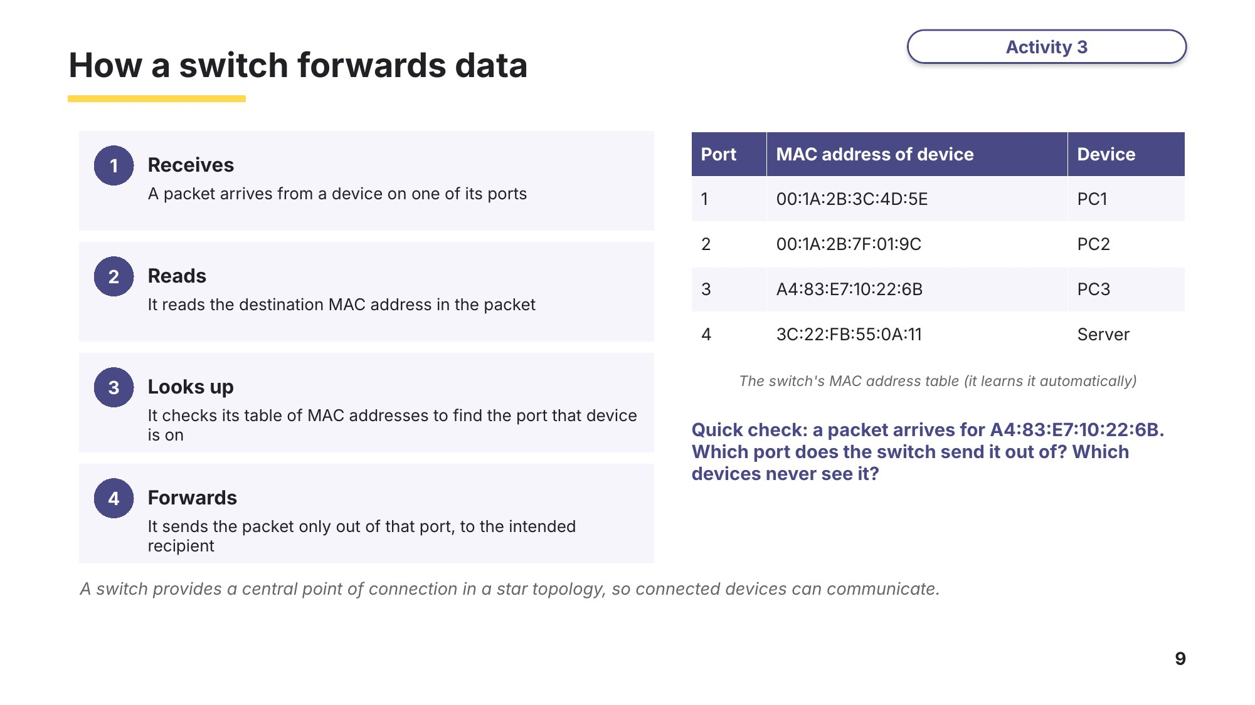
Slide 9 - How a switch forwards data
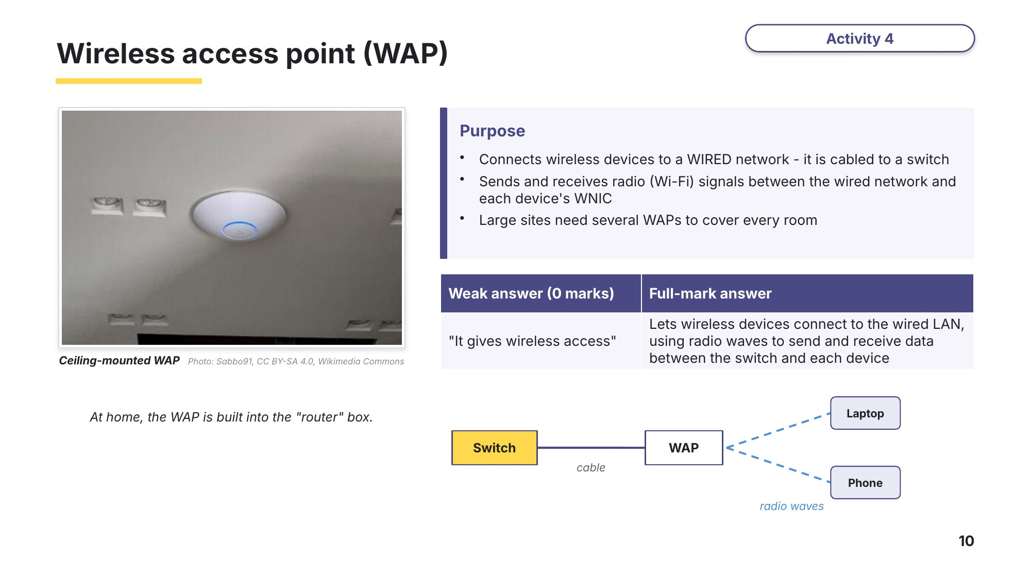
Slide 10 - Wireless access point (WAP)

Learn Servers, cables and longer links
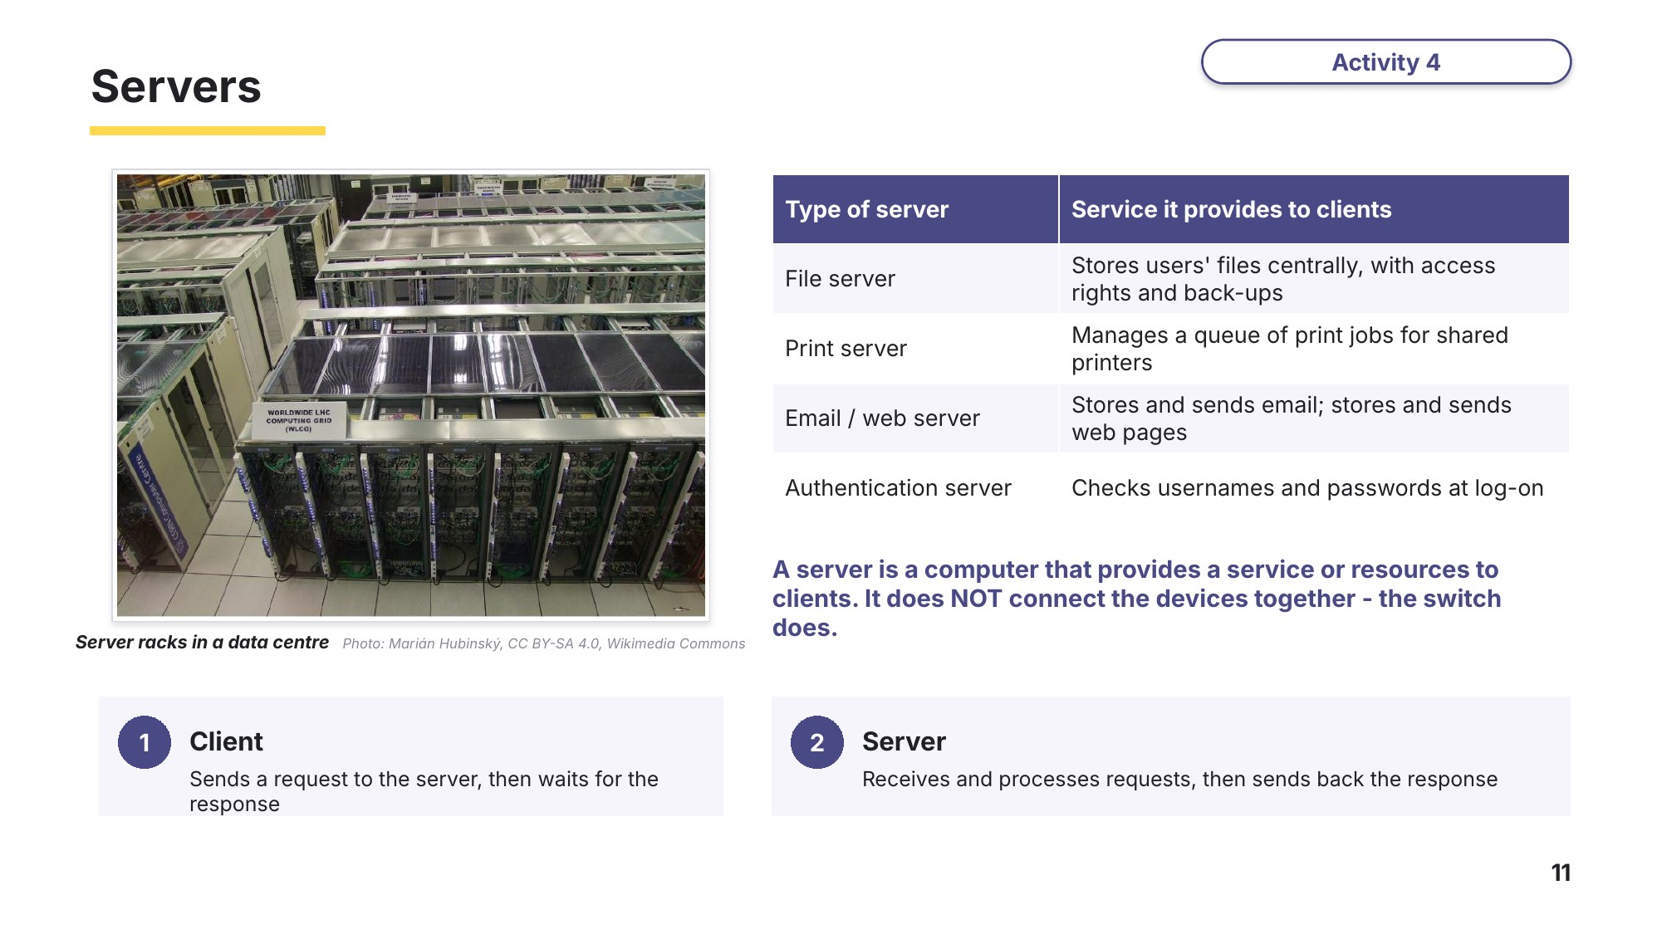
Slide 11 - Servers
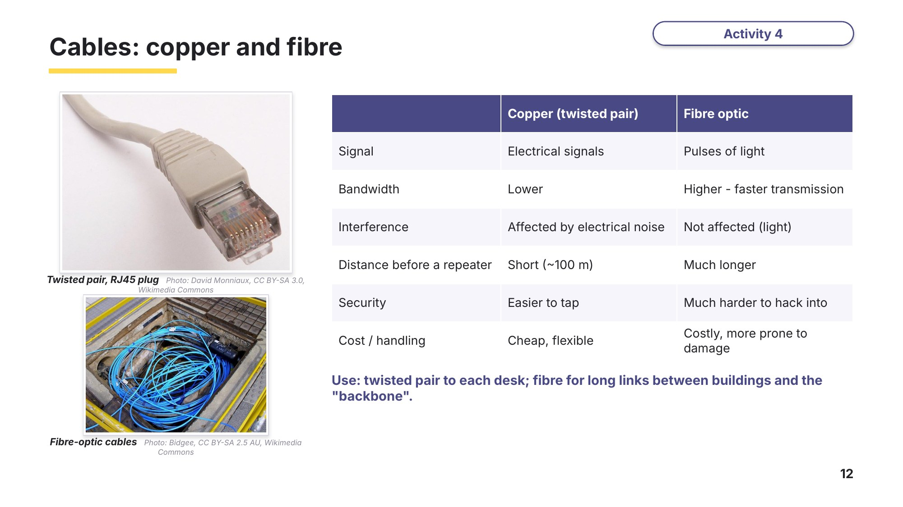
Slide 12 - Cables: copper and fibre
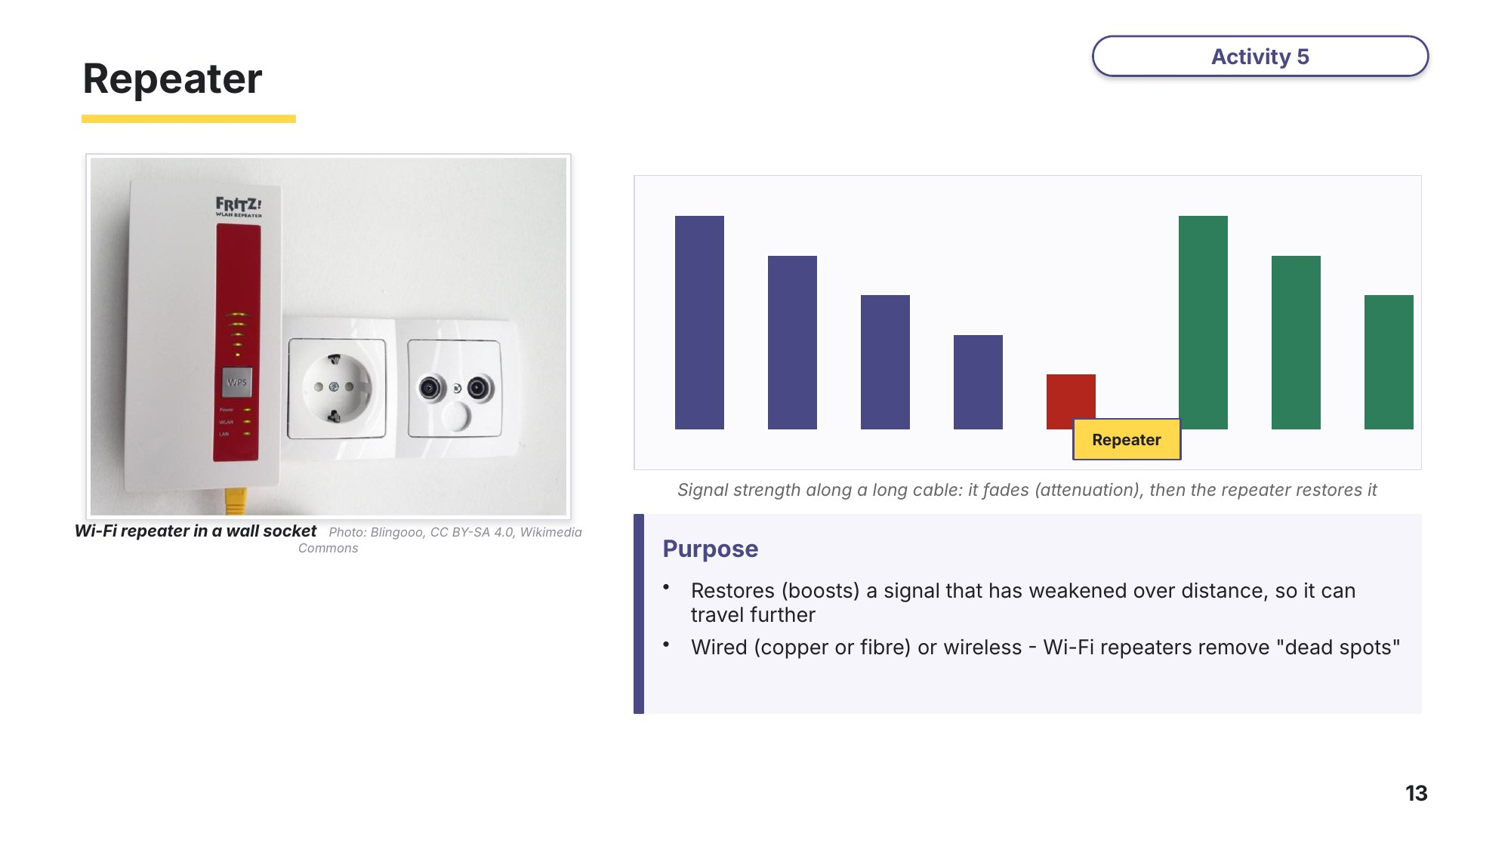
Slide 13 - Repeater
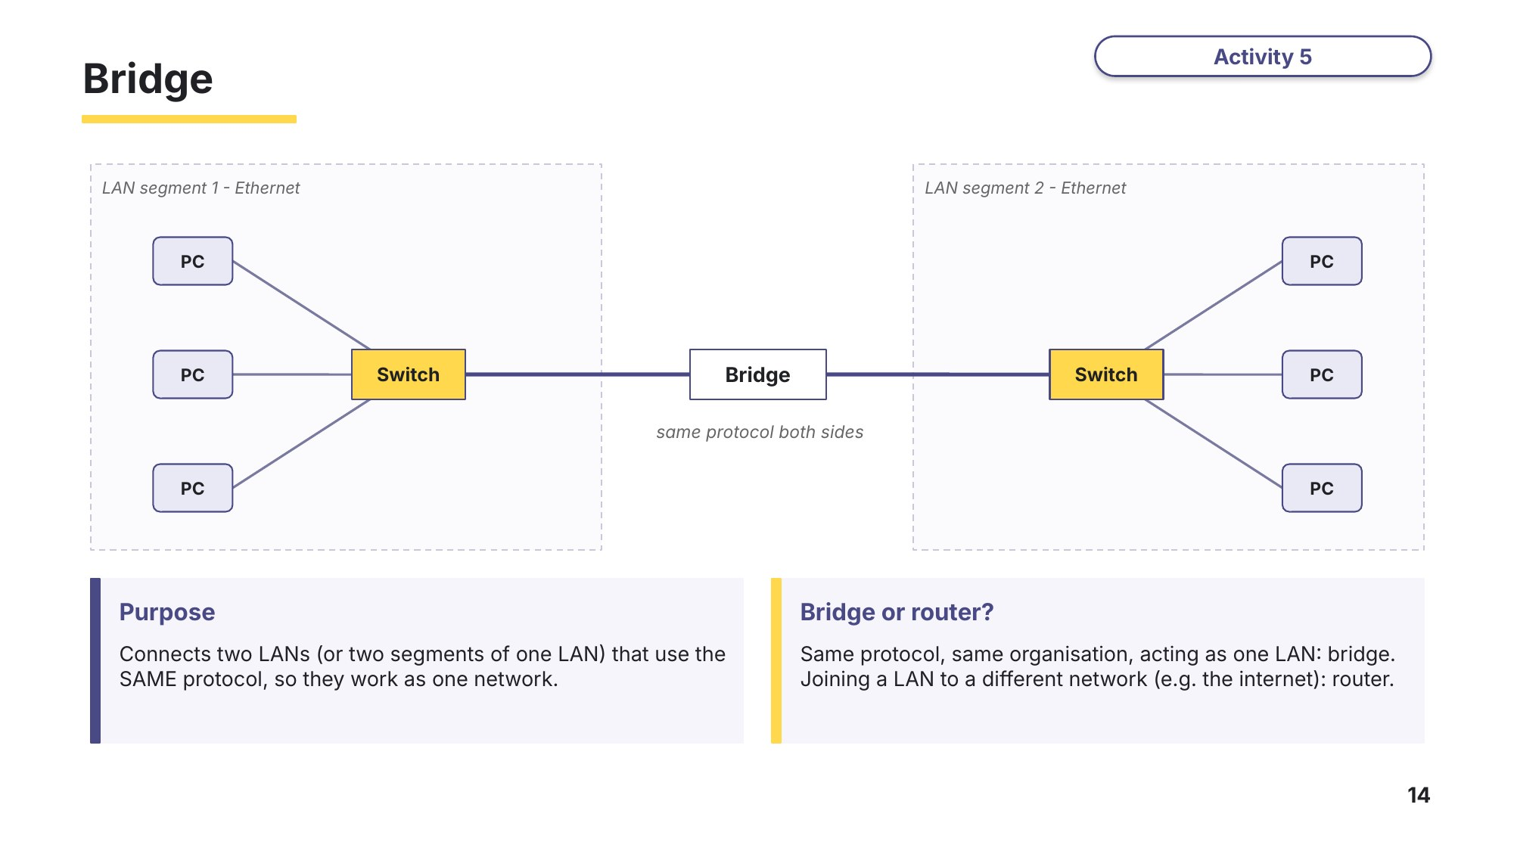
Slide 14 - Bridge

Learn The router and the modem
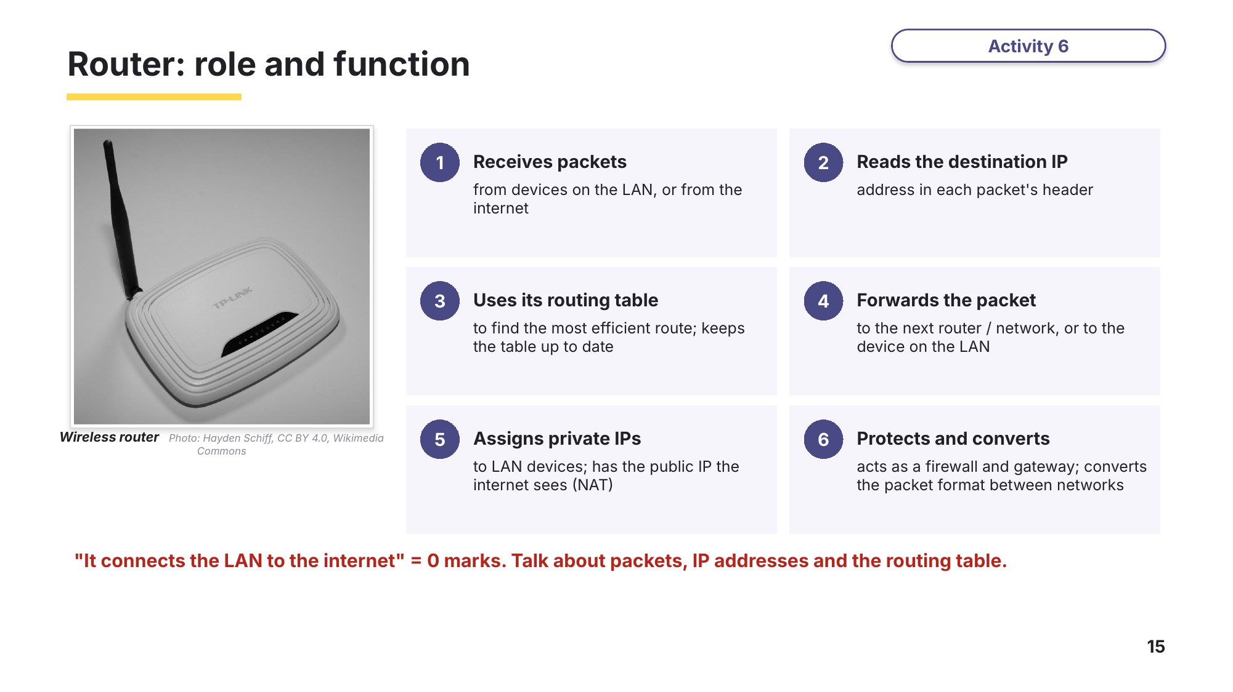
Slide 15 - Router: role and function
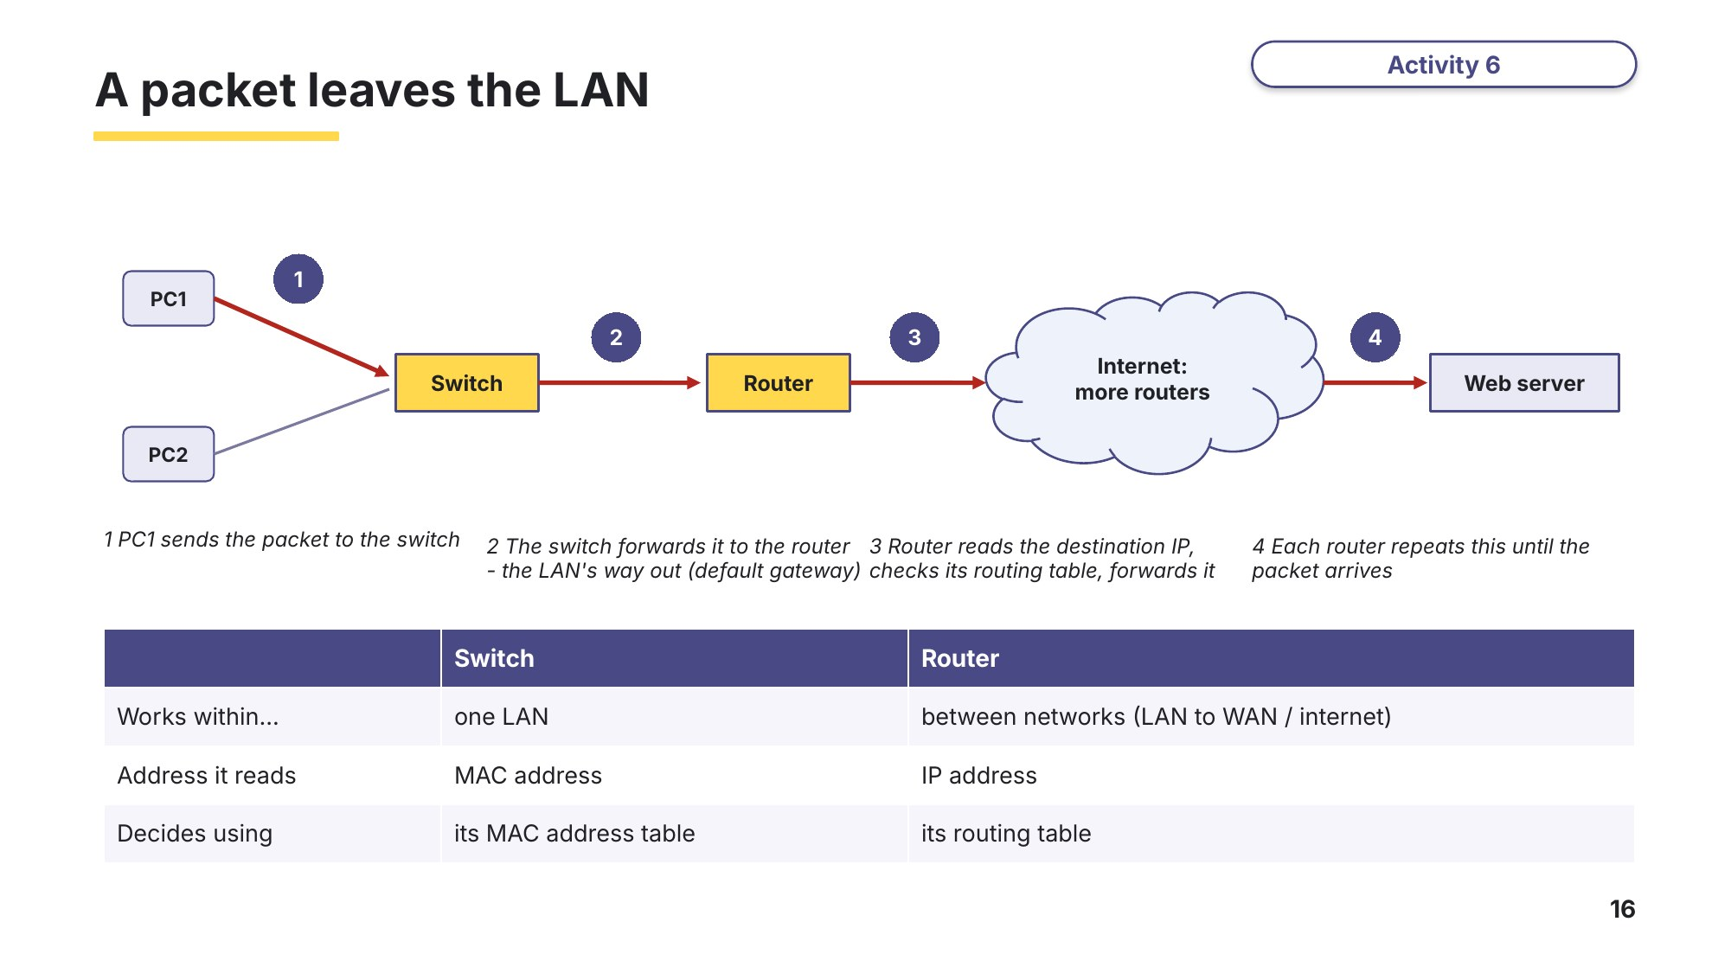
Slide 16 - A packet leaves the LAN
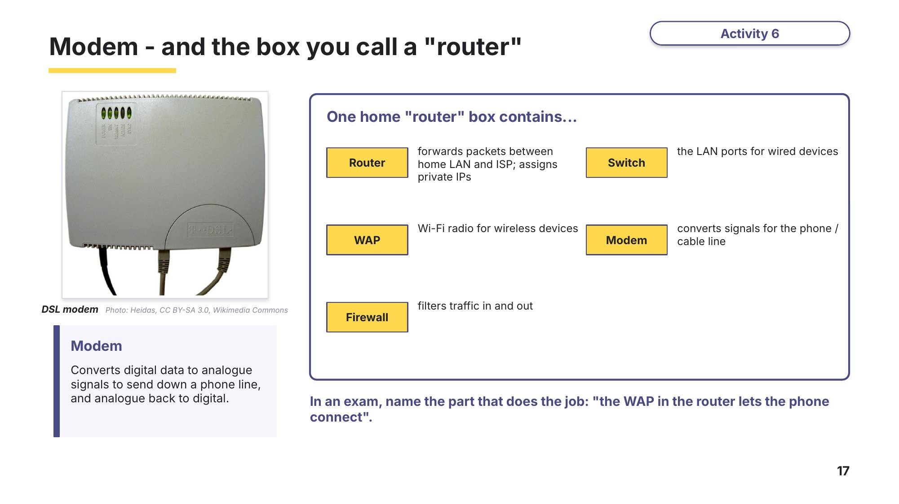
Slide 17 - Modem - and the box you call a router
Task 2 Identify the hardware [12 marks]
(a) The diagram shows a school network. The main building is linked to a sports hall 150 m away. Name the devices labelled A to H. [8]
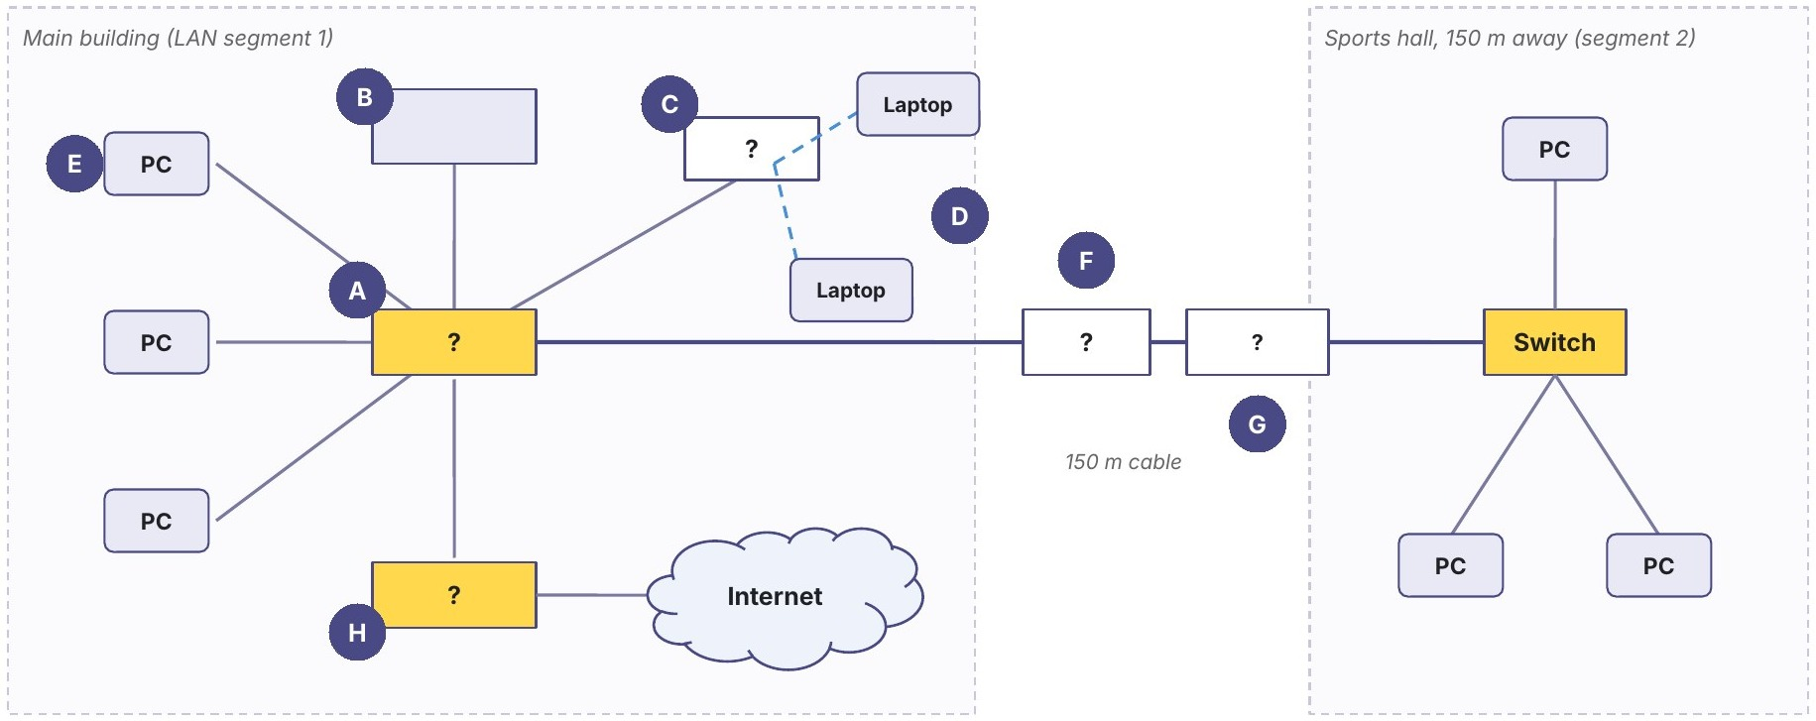
Label | Device | Label | Device
A |  | E
B |  | F
C |  | G
D |  | H

(b) The following incomplete table contains four network devices and their descriptions. Complete the table by writing the missing devices and missing descriptions. [4]
9618/12 May/June 2022 Q9(a).
Device | Description
 | Receives and sends data between two networks operating on the same protocol
Wireless Network Interface Card (WNIC)
 | Restores the digital signal so it can be transmitted over greater distances
Wireless Access Point (WAP)
Learn Check your answers to Task 2(a)
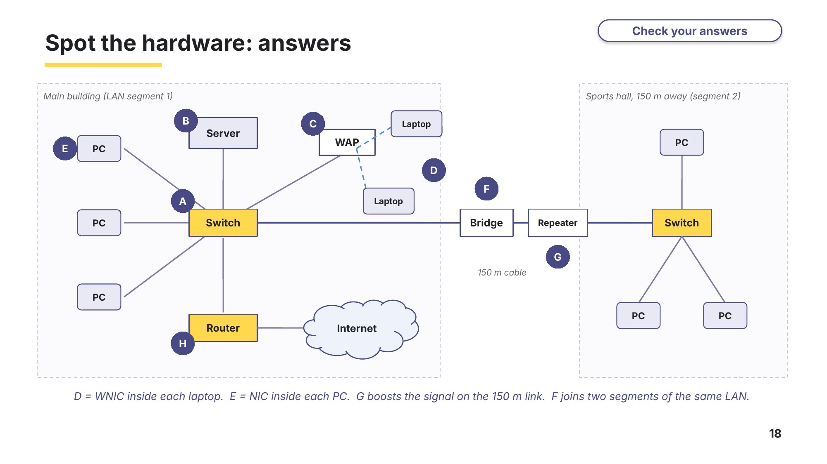
Slide 18 - Spot the hardware: answers

Task 3 Apply [10 marks]
(a) Melinda connects her laptop to the internet through her router. Tick one box in each row to identify whether the task is performed by the router or not. [2]
9618/11 May/June 2021 Q4(c)(i).
Task | Performed by router | Not performed by router
Receives packets from devices
Finds the IP address of a Uniform Resource Locator (URL)
Directs each packet to all devices attached to it
Stores the IP and/or MAC address of all devices attached to it

(b) Four computers, PC1 to PC4, are connected in a star topology. PC1 sends a packet to PC3. Tick every computer that receives the packet when the central device is a hub, and when it is a switch. [2]
Central device | PC2 | PC3 | PC4
Hub
Switch
Give two reasons why a school would use a switch rather than a hub. [2]
1

2

(c) Tick one box in each row to show whether each statement describes a MAC address or an IP address. [4]
Statement | MAC address | IP address
It is set by the manufacturer of the NIC or WNIC
A router reads it to forward a packet to another network
It can change when a laptop joins a different network
A switch reads it to decide which port to send data out of
Task 4 Exam questions - the router [7 marks]
A school has a Local Area Network (LAN).
(a) The LAN connects to the internet using a router. Describe the function of a router in a network. [3]
9618/11 October/November 2023 Q2(a).

(b) Describe the role of routers in the transmission of data through the internet. [2]
9618/12 May/June 2024 Q3(c)(i).

(c) A LAN consists of a router, two laptop computers and a server, connected in a star topology with the router as the central device. Explain how data is transmitted between the two laptops in the LAN. [2]
Based on 9618/12 October/November 2023 Q7(b)(ii).

Learn Exam technique - check your Task 4 answers
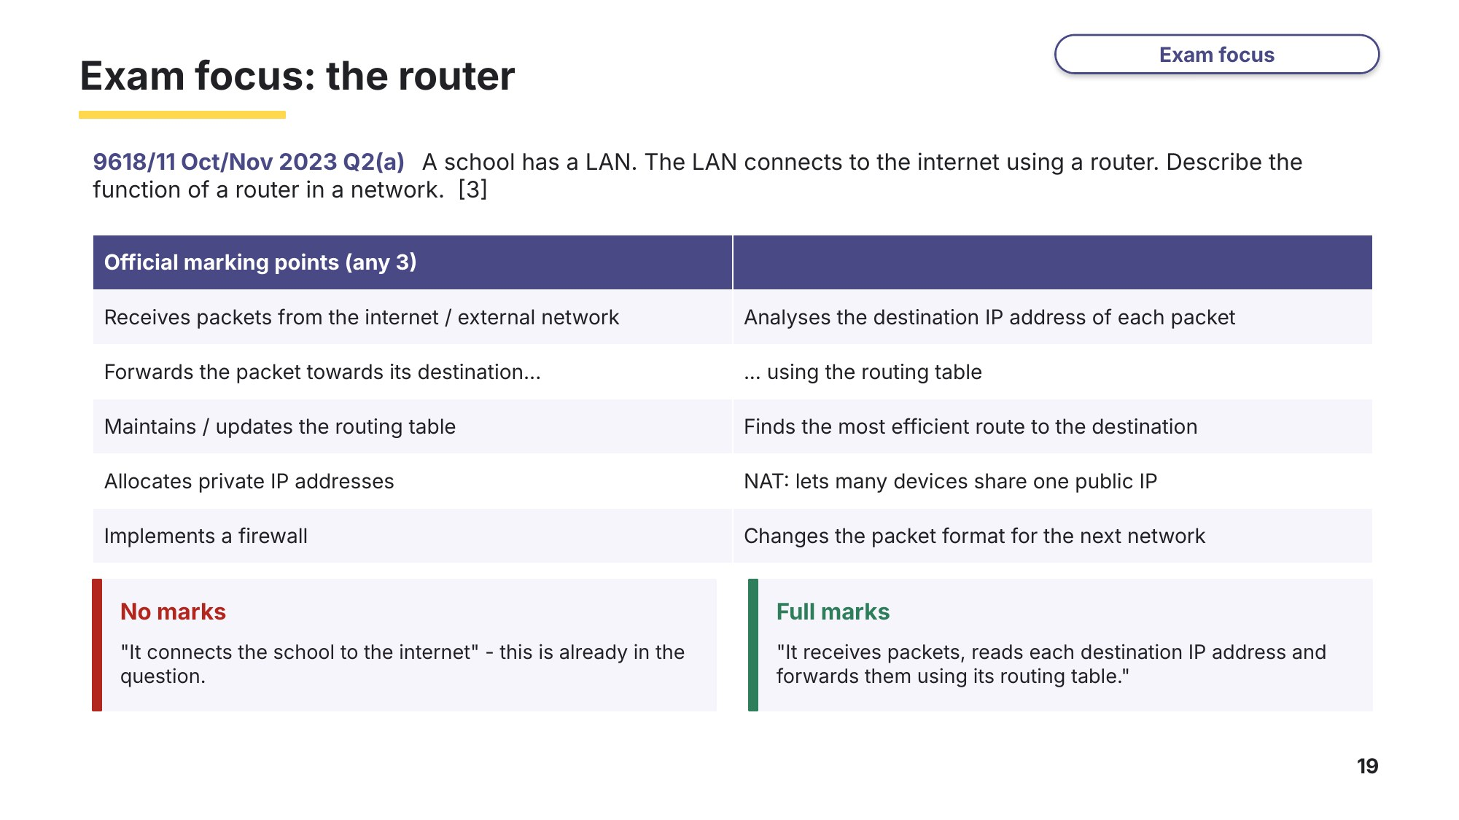
Slide 19 - Exam focus: the router
Task 5 Exam questions - LAN devices [12 marks]
(a) Complete the following table by writing the purpose of each of these other hardware devices used to support the LAN. [3]
9618/11 October/November 2023 Q2(b).
Hardware device | Purpose
switch
Wireless Access Point (WAP)
bridge

(b) Describe the role of a switch in a network. [3]
9618/12 May/June 2025 Q6(e).

A school is setting up a network within one of its buildings.
(c) One classroom has 30 computers. Each computer has a network interface card (NIC). Identify two possible devices that can be used to physically connect the 30 computers to the rest of the network. [2]
Based on 9618/11 October/November 2021 Q8(b).
1

2

(d) The school's laptops each have a Wireless Network Interface Card (WNIC). Describe the functions of a WNIC. [4]
Based on 9618/11 October/November 2021 Q8(c).

Learn Exam technique - check your Task 5 answers
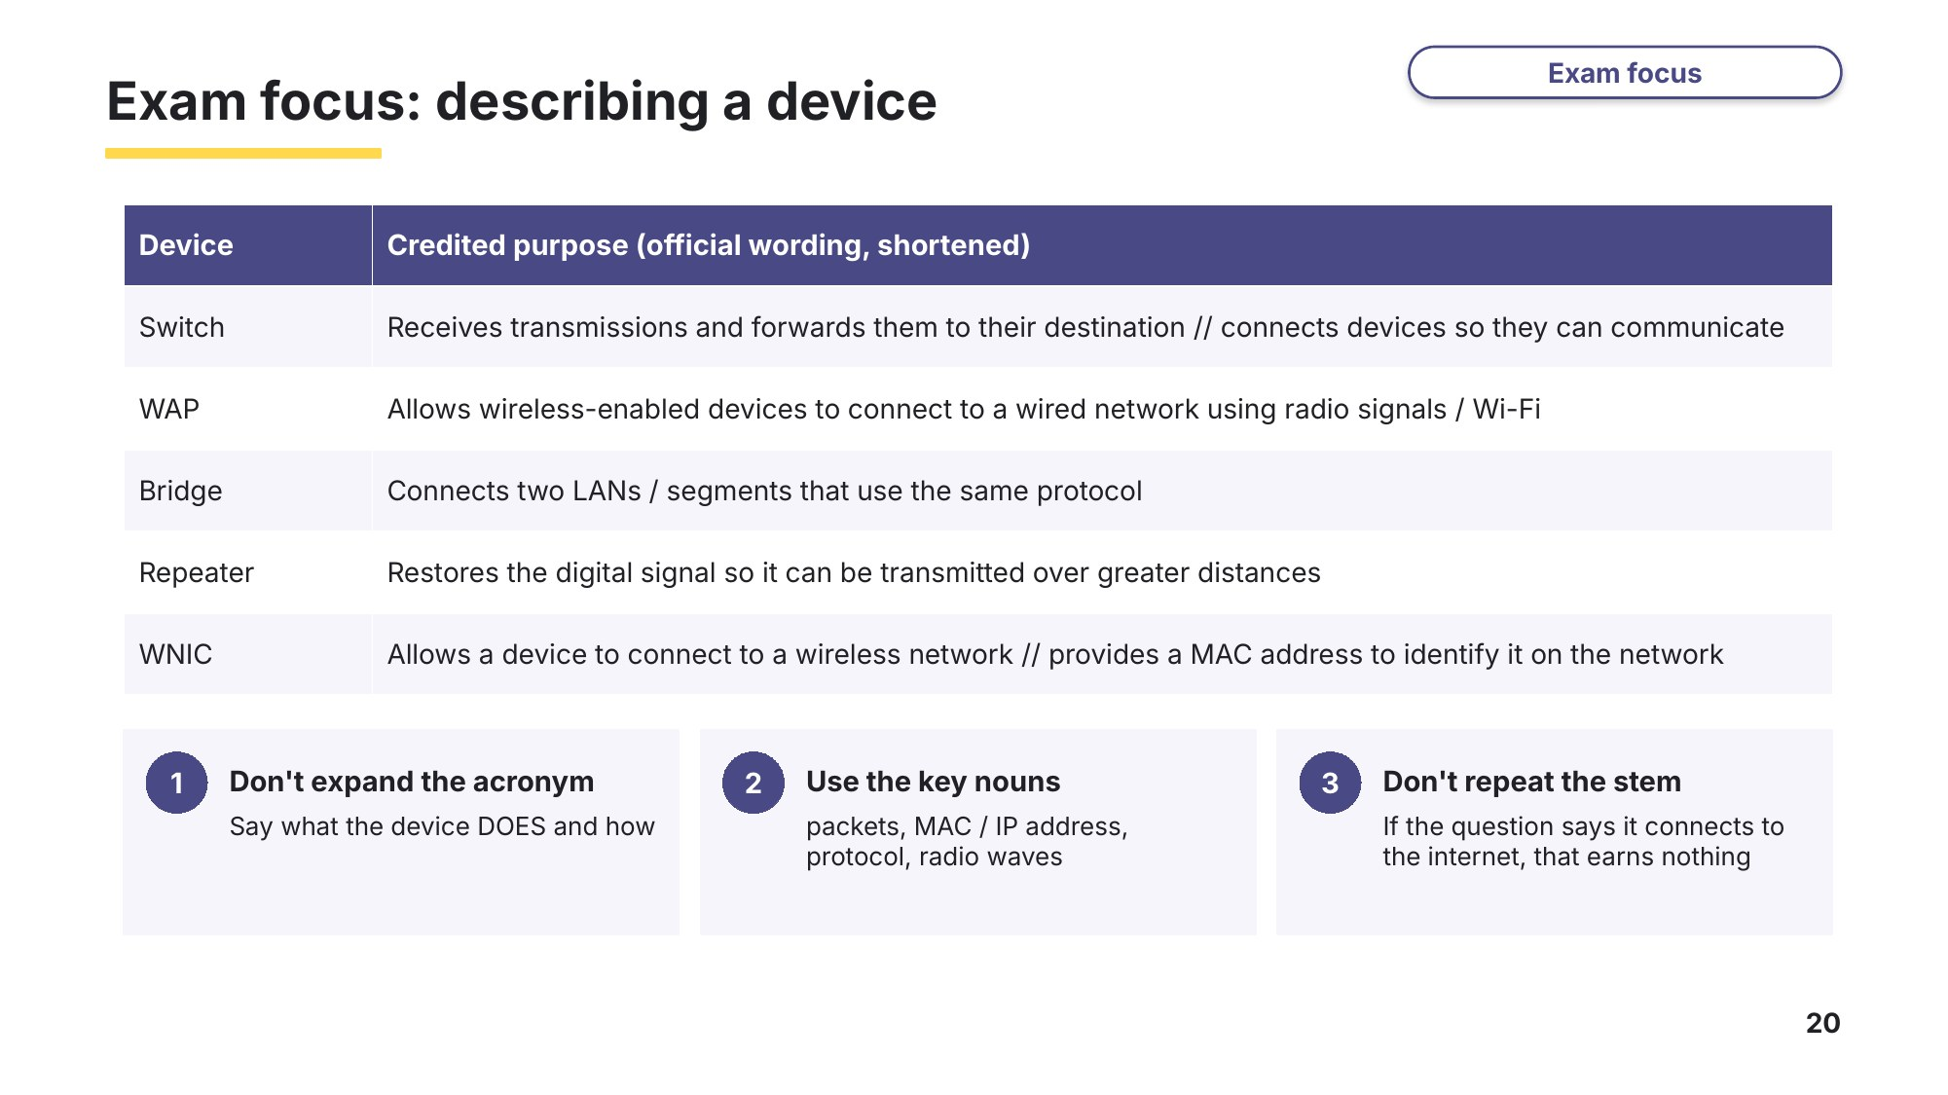
Slide 20 - Exam focus: describing a device
Task 6 Extension or homework [10 marks]
(a) The main office for a company has four wired computers, one server, two printers, one central switch and a device providing a single point of access for the internet. The network is set up as a star topology. Draw the topology for the main office network. Label all devices. [4]
9618/12 May/June 2025 Q6(d).

(b) The school in Task 2 is building a new library 400 m from the main building. The library will have 20 desktop computers, a printer and Wi-Fi for up to 60 student laptops, and must share the school's file server and internet connection. Describe the hardware the library needs, and justify each choice. You may draw a diagram. [6]

Learn Review
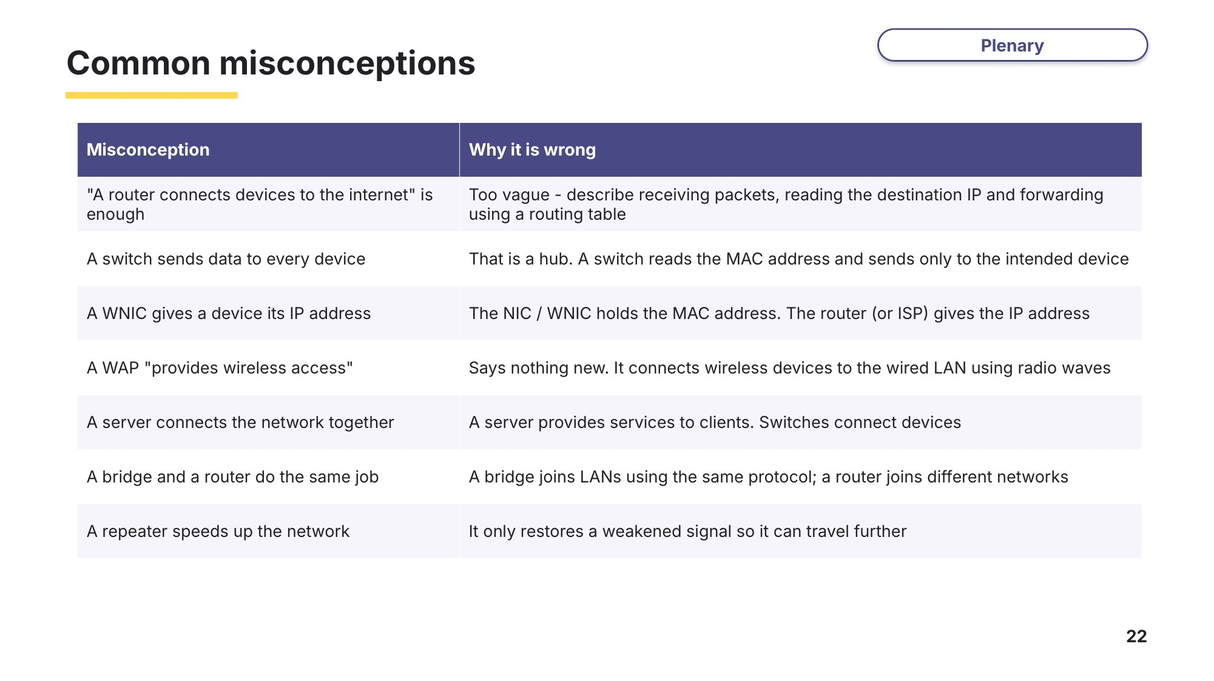
Slide 22 - Common misconceptions
Look back at your Task 1 answers and at the misconceptions above. Which did you believe before this lesson?
Exit question
(a) Explain why a school uses a switch rather than a hub to connect 30 computers. [2]

(b) State one difference between a bridge and a router. [2]

